Ex. No. 2 | ARITHMETIC OPERATIONS USING UiPath
Date of Exercise | 04/12/2025

AIM
To perform arithmetic operations on two numbers using UiPath.
DESCRIPTION
This experiment is used to automate basic arithmetic operations on two input numbers using UiPath Studio. In this workflow, two numbers are taken as input (from the user or assigned in variables) and operations such as Addition, Subtraction, Multiplication, and Division are performed using UiPath activities and expressions. The calculated results are then displayed using a Message Box or Output panel, helping to understand the use of variables, data types, and calculations in UiPath automation.
PROCEDURE:
Step 1: Open UiPath studio and click process to start a new project.
Step 2: Create a new blank process by giving a name and give create.
Step 3: Click Open main workflow.
Step 4: From activities select Two Input dialog box and drop it. Type the Dialog title, Input label and value entered in both the dialog box.
Step 5: For the value entered num1, num2 create variable num1, num2 and select variable type as INT32.
Step 6: From activities select message box and drop it in main workflow. Type num1+num2.
Step 7: As like addition, Subtraction, Multiplication, and Division can be performed.
Step 8: Save it and run the sequence.

OUTPUT:
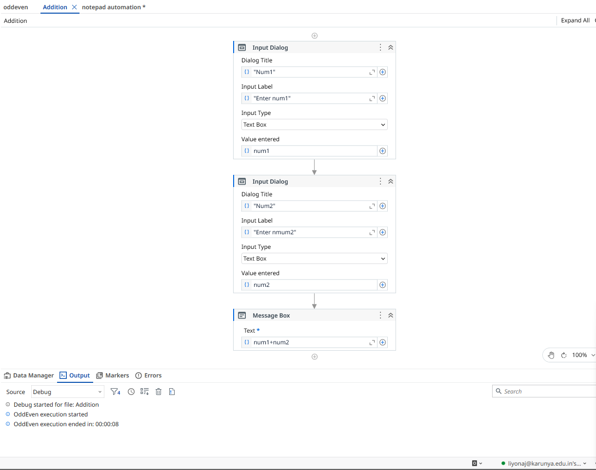

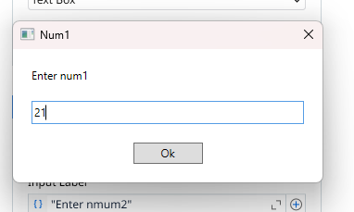
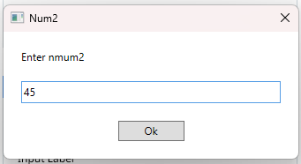

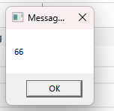

Result
Thus, the arithmetic operations are performed successfully.

